
SINGHANIA EDUCATIONAL INSTITUTE

Computer Science
Practical File 2023-24

Name:
Class: Section:
Roll no:

Under the Guidance of:
Mr.Mohd Imran Khan
PGT (COMPUTER SCIENCE)

ACKNOWLEDGEMENT

I would like to express a deep sense of thanks & gratitude to my project guide Mr. Imran Khan for guiding me immensely through the course of the project. He always evinced keen interest in my work. His constructive advice & constant motivation have been responsible for the successful completion of this project.

My sincere thanks goesto Mr. Harish Choudhary, Our principal sir, for his co-ordination in extending every possible support for the completion of this project.

I also thank my parents for their motivation & support. I must thank my classmates for their timely help & support for compilation of this project.

MYSql TABLE
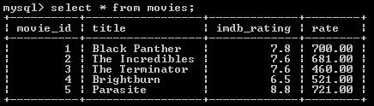

#CREATE TABLE movies(movie_id INTEGER(4),title VARCHAR(20),imdb_rating FLOAT(2,1),price FLOAT(5,2))

import mysql.connector as m

mydb=m.connect(

host='localhost',

user='root',

passwd='123456',

database='db1'

)

cur=mydb.cursor()

d=1

while(d==1):

print("NOTE : IMDB rating is a rating scale that allows users to rate films on a scale of one to ten")

print("1. Add records")

print("2. Delete a particular record")

print("3. Update a record acc. to movie_id")

print("4. Search a record")

print("5. Display all records")
print("6. Buy tickets")

print("7. Exit")

choice=int(input("enter the no. of your choice : "))

if (choice==1):

length=[]

i=int(input("enter movie id : "))

length.append(i)

t=input("enter movie title : ")

length.append(t)

im=float(input("enter movie's imdb rating : "))

length.append(im)

pr=float(input("enter movie's price : "))

length.append(pr)

s="INSERT INTO movies VALUES(%s,%s,%s,%s)"

q=length

cur.execute(s,q)

mydb.commit()

if(choice==2):

s="DELETE FROM movies where movie_id=%s"

i=int(input("enter movie id : "))

q=(i,)

cur.execute(s,q)

mydb.commit()

if(choice==3):

i=input("enter the movie which you want to update : ")

n1=input("enter new name of the movie : ")
n2=float(input("enter the imdb rating of the movie : "))

n3=float(input("enter the price of the movie : "))

s="UPDATE movies SET title='{}', imdb_rating={} WHERE title='{}'".format(n1,n2,i)

cur.execute(s)

mydb.commit()

if(choice==4):

print("enter 'a' to search a record using movie id : ")

print("enter 'b' to search a record using title : ")

ch=str(input("enter your choice : "))

if ch=='a':

i=input("enter the movie id you want to search ")

R=("select*from movies where movie_id=%s")

v=(i,)

cur.execute(R,v)

r=cur.fetchall()

for i in r:

print(i)

if ch=='b':

i=input("enter the movie title u want to search ")

R=("select*from movies where title=%s")

v=(i,)

cur.execute(R,v)

r=cur.fetchall()

for i in r:

print(i)

if(choice==5):

s="SELECT * FROM movies"
cur.execute(s)

for i in cur:

print(i)

if(choice==6):

r=0

if(r==0):

i=input("movie title : ")

j=int(input("no. of tickets : "))

sel="SELECT PRICE*{} FROM movies WHERE title='{}'".format(j,i)

cur.execute(sel)

f=cur.fetchone()

for i in f:

f=[i]

print("Total Price = Rs ",i)

list=[]

list.append(i)

r=r+1

print("Have a great time !!")

if(choice==7):

d=0

else:

print("enter choice from 1 to 7")

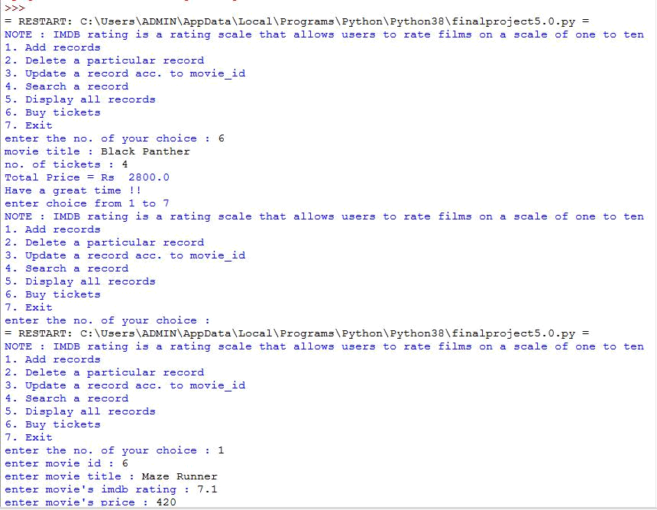
OUPTPUT
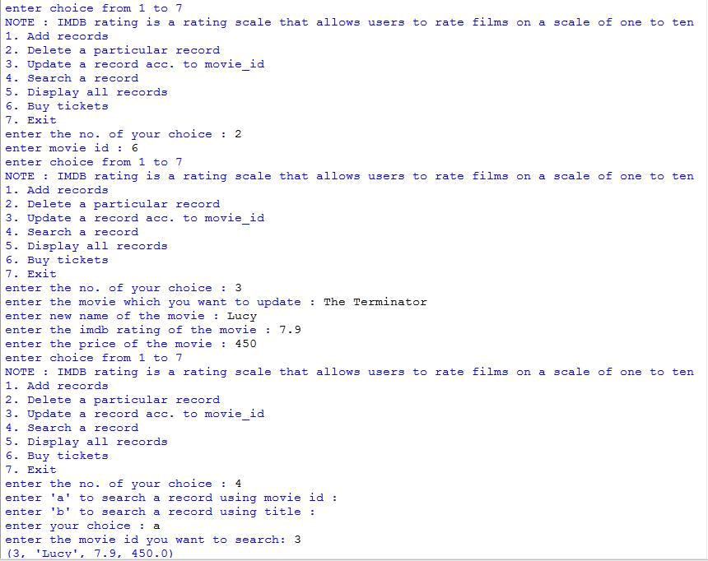
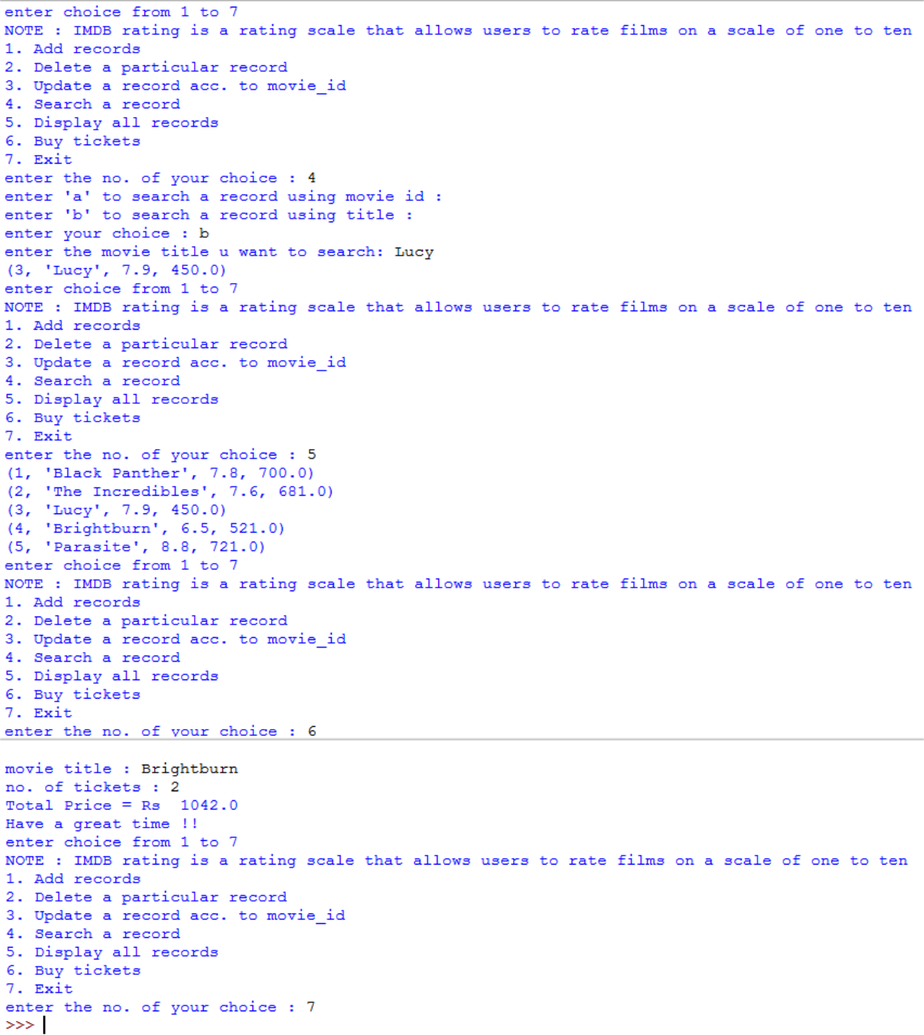

Bibliography

- Computer Science with Sumita Arora
- Computer Science with Preeti Arora
- www.w3resource.com
- Under the guidance of subject teacher

